* Introduction to Android Platform
* Installations Required
* Understanding Android Virtual Device
* Connecting a real device
* Understanding Android SDK Manager
* Android ADB
* DDMS



What is Android?

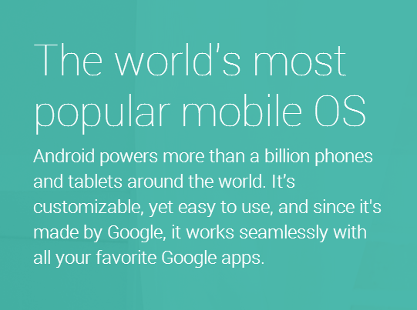

Android versions identity

Each android release has two separate identities

1. Platform version – Identified by the decimal formatted values 2.1 , 4.1 , 4.4.1 etc.
2. API level – Important to developers (different naming system – simple Integer). It exposes the various SDK features. Ex. 1, 2…..18
3. Platform version and the API relationship – Each platform version supports a specific API level.

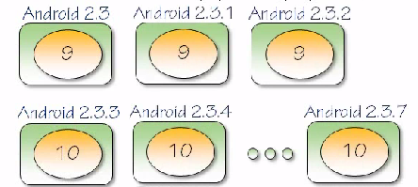

**Programming in Android**

Android is built in such a way that you can work with it in different environments (flexible and not tied to a single development environment).

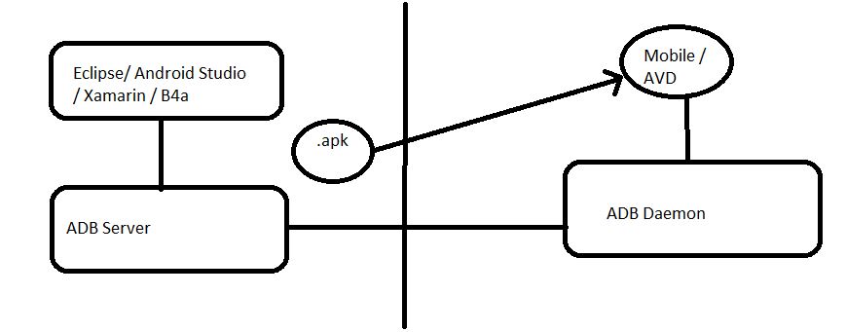

**Android Debug Bridge (ADB)**

It makes the communication between the desktop and mobile devices possible.

Finding the ADB command line utility in the Android folder

<install-folder>\sdk\platform-tools

* adb devices command

Shows the list of devices connected (actual devices and AVD’s)

* If things are not working correctly then you can always do the

adb kill-server command

* You can then run any adb command or use the start-server command to start the server

Xamarin Platform

Xamarin apps share code across all platforms.

Target iOS, Android, Windows and Mac with a single, shared C# codebase. Use the same language, APIs and data structures on every platform.

C# is the best language for mobile app development.

With Xamarin, you write your apps entirely in C#, sharing the same code on iOS, Android, Windows, Mac and more. Anything you can do in Objective-C, Swift or Java, you can do in C#.

Native UI, native API access & native performance.

Xamarin apps are built with standard, native user interface controls. Apps not only look the way the end user expects, they behave that way too. This can’t be achieved with other solutions.

**Installation**

1. Java JDK 7
2. Android SDK
3. Eclipse / Android Studio / Xamarin Studio
4. Configuring the IDE

**Android Studio (uses Java)**

<http://developer.android.com/sdk/index.html>

**We will be using Xamarin Studio (uses C#.net)**

Create a Xamarin user and download the Xamarin Universal Installer.

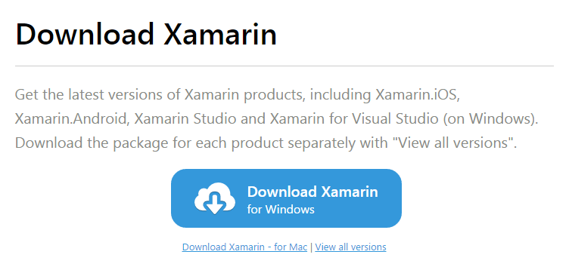

I will share the installer with you.

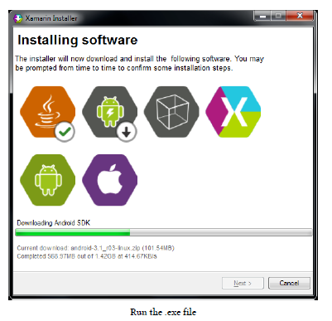

**Register for a Student Account**

https://xamarin.com/student

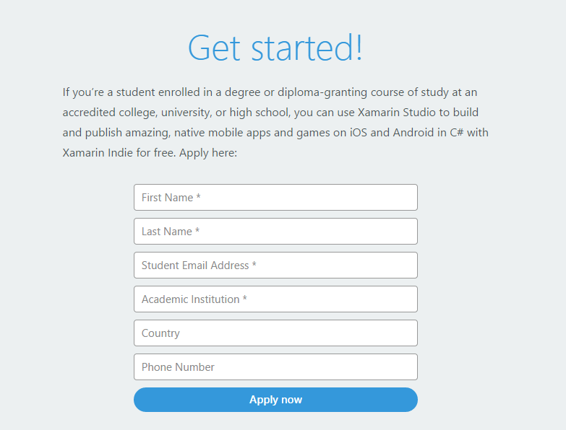

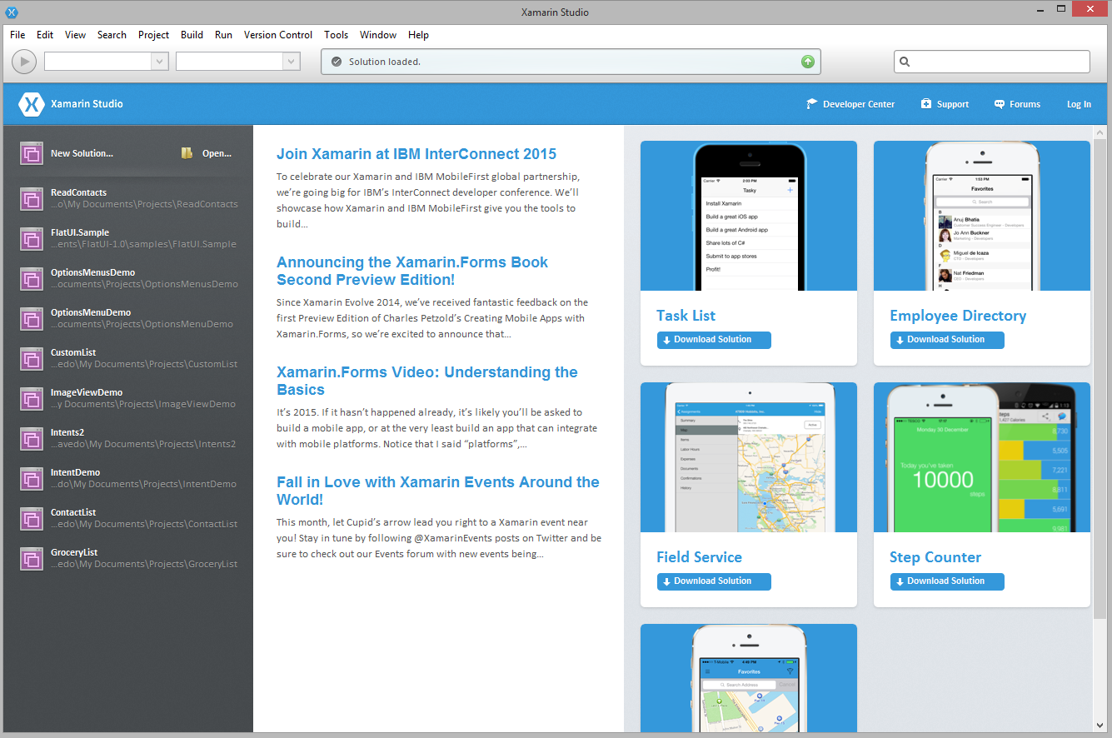

**Configuring**

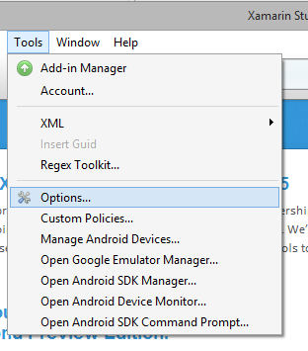

See that you’re SDK paths are properly pointing to the right location. It should install properly using the Universal Installer, however if you’re installing it separate then you may have to configure it manually.

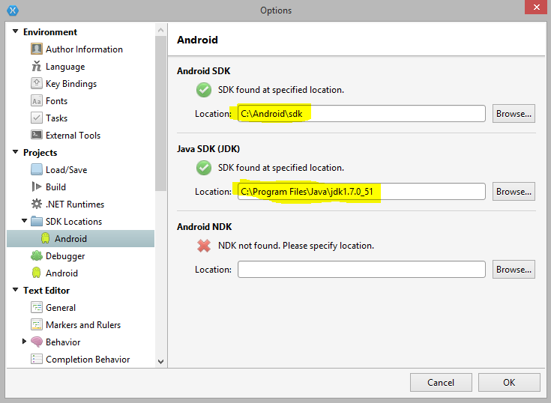

**Android SDK Manager**

Helps you install newer version of the Android SDK and the tools associated with it.

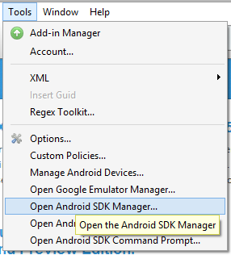

Android SDK manager.

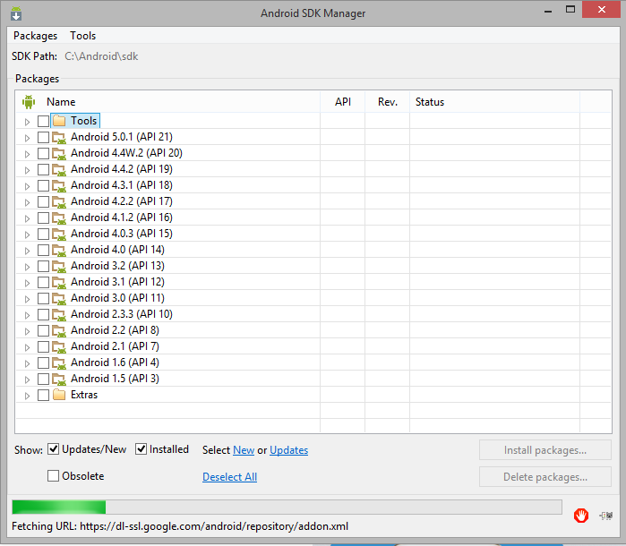

Documentation

<http://developer.android.com/index.html>

<http://developer.android.com/about/dashboards/index.html>

**last year**

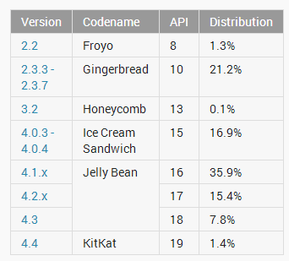

Current

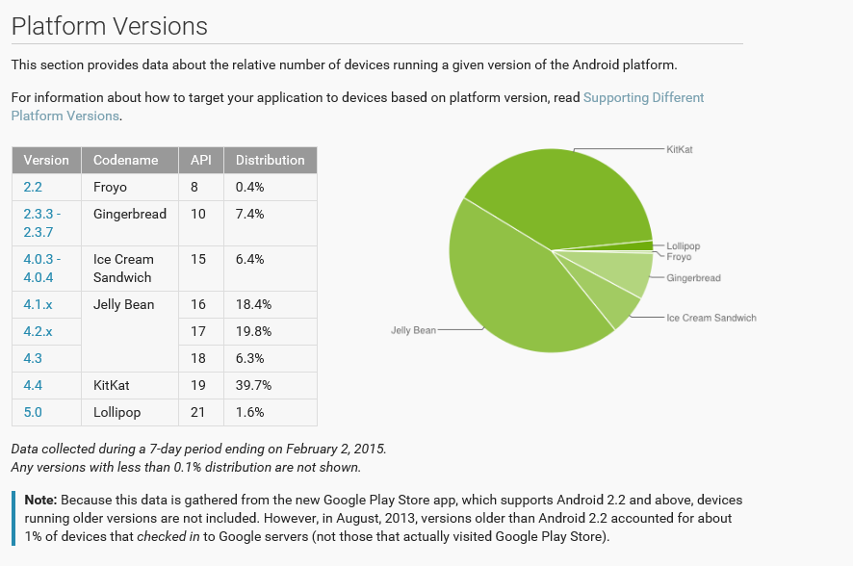

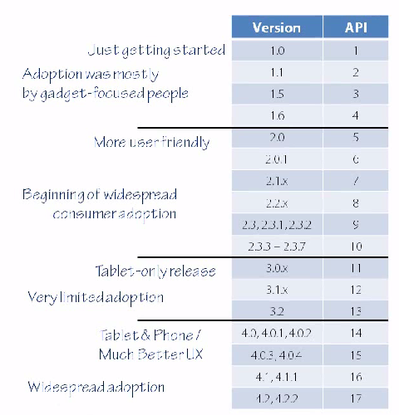

**Specifying an SDK level for an App in Xamarin Studio**

Go to Project - > (Project Name) Options

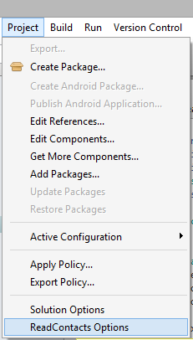

Select the android version to support.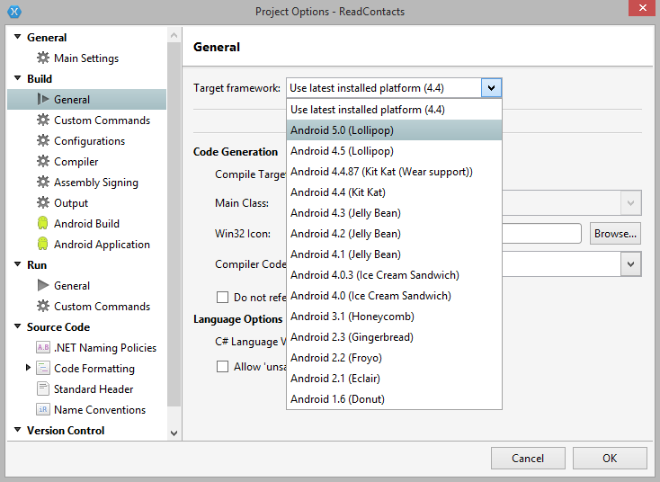

**Debugging and Testing your App**

Android Virtual Devices (AVD) or emulator

* Allows you to test your app on a desktop
* Android devices highly vary
* Lot of different target environments
* Create an AVD definition to describe the characteristics of a device
* Screen characteristics
* Physical keyboard
* GPS
* Camera

Create an AVD image to work with based on a AVD definition

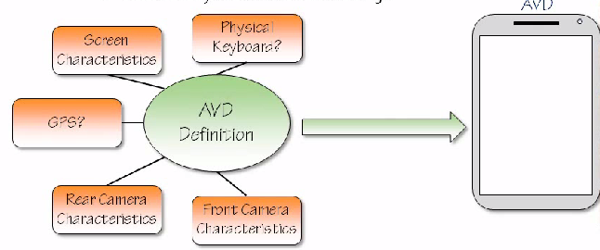

Changing the definition after the image has been created does not change the image.

We still need a device but not every possible device is needed. Emulators come in handy for testing on different environments and screen sizes.

Accessing the AVD.

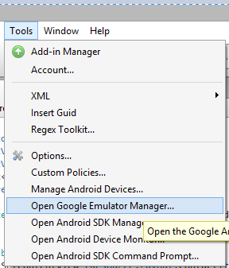

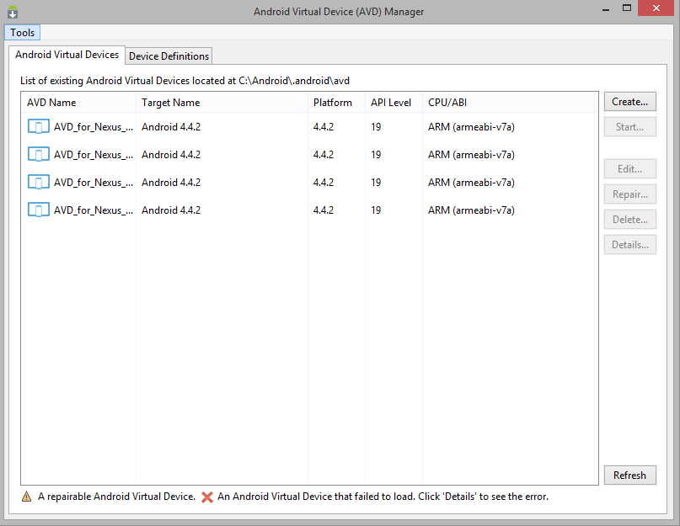

AVD’s can have device definitions based on

* Real device
* Generic device definitions

Real Device



Generic Device Definitions



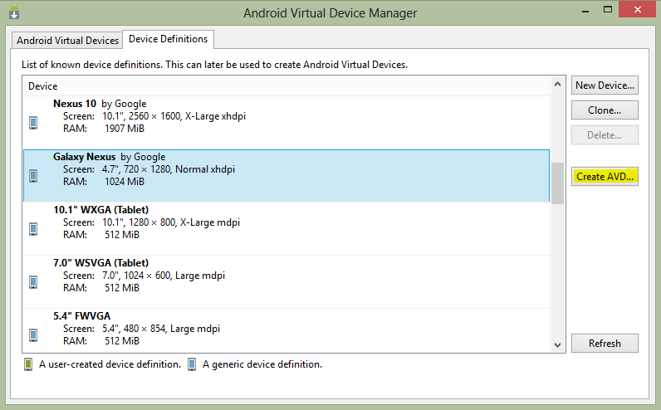

* Choose your destination device
* Click Create AVD
* Set the options and feature and click OK

Starting the Android Virtual Device

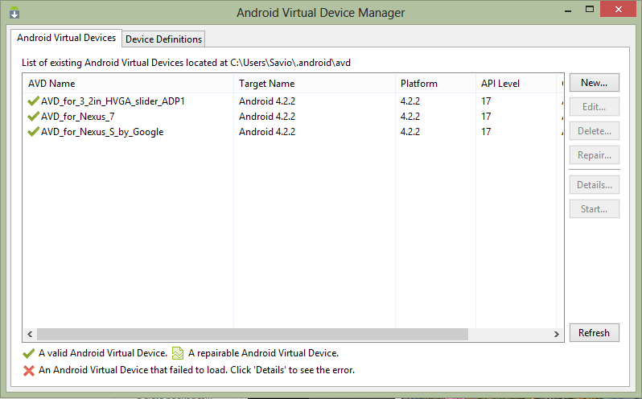

Click on a device and press start.

It may take a long time to start for the first time.

The emulator then starts up as shown.

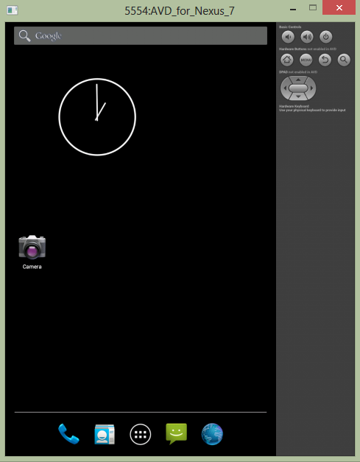

**Connecting an Actual Device**

AVD’s are not exactly the perfect replication of a real device.

* Some features are difficult to simulate such as the performance speed, GPS behaves differently.

Debugging on a real device requires extra setup

* Enable USB debugging on phone
* Install USB drivers on your desktop computer

Hooking the mobile and computer together is called Tethering

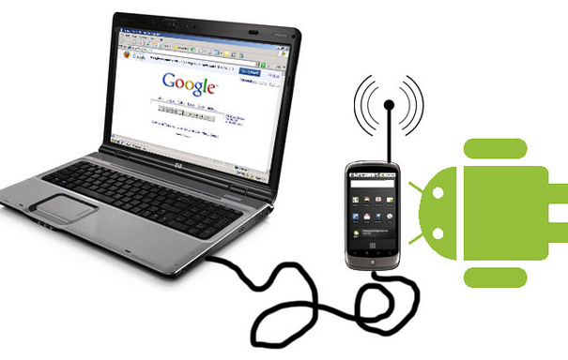

Phones by default do not have USB debugging enabled

Locating the USB debugging checkbox on your Android phone

< 4.0 Settings -> Applications -> Debugging

4.0, 4.1 Settings -> Developer Options

> 4.2

Developer Option is hidden

Settings -> About -> Build Number (Tap the build number **7** **times)**

It becomes available in the previous screen

The USB driver enables development tools to communicate with device

* Most Android Developer Phones use the Google USB driver

(Nexus 1 and Nexus S) (Available through SDK manager)

* Galaxy Nexus relies on Samsung provided driver
* For all other phones you must download the manufacturer drivers

<http://developer.android.com/tools/extras/oem-usb.html>

**Set the “Stay Awake” option**

The device going to sleep can be disturbing while debugging.

Set it in the developer options or download an app from the playstore.

**DDMS (Dalvik Debug Monitoring System)**

Android tool that provides a whole bunch of debugging features.

sdk\ tools

